Faro Arm User Guide

Haley Hashemi, 2023
Open Source Instruments, Inc.

Contents:
- Workspace and Project Management
  - Workspace v Project
  - Creating or loading a project
- Connecting software to FARO arm
  - Connecting
  - Calibration
- Coordinate Systems
  - Loading pre-made coordinate system
  - Measuring new coordinate system features
  - Setting the coordinate system
- Basic Features
  - Measuring features
  - Extracting features
- Flange Method
  - LWDAQ/CPMS Manager
  - Faro flange measurements
- Exporting Data
- Troubleshooting

- Workspace and Project Management
  - Workspace v Project
    - A workspace is a place where one can store multiple projects. Think of this as a directory head, and within the workspace multiple sub-directories/projects can be made.
    - A project is the actual polyworks software file you are using to manage your experiment, and it is saved within a workspace. Typical nomenclature is to name each workspace and project after the date, unless there are multiple projects- then be more specific with the project names within the workspace.
  - Creating or loading a project
    - Open up polyworks on the computer, which opens up to the workspace manager.
    - To create a new project, you must select a workspace to save the project in. You can create a new work space or use a previously made one. These commands can be found in the toolbar.
    - Once a workspace has been created or loaded, either create a new project or double click an existing one in the workspace manager. To create a new untitled project, select the orange polyworks inspector icon in the toolbar. This will open up a new project file.

- Connecting software to FARO arm
  - Connecting
    - Turn the FARO arm on, once the FARO arm light stops flashing, it is ready to connect.
    - In the bottom left corner of the polyworks project, select the arrow on the “Connect to Faro Arm” icon. Then, select faro arm.
    - A diagram may pop up on the screen that displays the Faro arm with red lines around the different hinges of the arm. This is a request to move the faro arm about its hinges to activate it. Move the arm gently about its hinges until the image disappears.
  - Calibration
    - I recommend doing this once a day. Select the “Probing Device Properties” icon in the bottom toolbar.
    - Use the Device list to select the faro arm, and click “Select Probe”.
    - Select “Hole Calibration”, and “Start Calibration”.
      - Before calibrating: Screw the compensation artifact device into the stage. Make sure that you can reach all slots in the device with the arm easily.
    - Put the probe into the compensation artifact. Press and hold the green button on the probe as you move it through each of the axes in the artifact. Hold green as you press into each slot, then release.
    - To finish the calibration, hit the red button.
    - The polyworks software provides a walk through for this if you are confused. Once you obtain a passing value, hit “Save and exit”.

- Coordinate Systems
  - Loading pre-made coordinate system
    - To avoid having to re-measure the spheres for the coordinate system every time, it is best to measure the spheres ~ once a month, and save them in a special calibration file, named <date><calibration>. The steps below describe loading a previously made system. Further on are steps to make a coordinate system.
    - File→ Load→ Select the most recent workspace that is named “Date-Calibration”--> select the project within→ select all of the Cone,Slot,Flat objects→ Import.
  - Measuring new coordinate system features
    - Select the “Create Features” icon in the upper toolbar, which will open up features creation space
    - Select the sphere Icon for the type of feature, and set the method to “Probe”.
    - To probe a point on an object, touch the probe to the object and hit the green button on the FARO arm. For spheres, take ten probing points. Once you have taken the last point, hit the red button to compensate for the arm and finish the object. Do this for each sphere in the coordinate mounts. They should be around ~6.4-5 mm in diameter. If they are significantly smaller or larger, please re-measure.
    - Measure and name the spheres in this order:
      - Cone, Slot, Flat, ConeL, SlotL, FlatL, ConeR, SlotR, FlatR
    - Save the project and workspace. Do not actually set the coordinate system, because the purpose of this project file is to load the spheres into future projects to avoid re-measuring every time you create a project. If you create a coordinate system using these spheres and do not set the active coordinate system to “world”, importing the spheres into future projects will disturb the faro arm’s own coordinate system.
  - Setting the coordinate system
    - This step occurs after you load the coordinate system spheres from another project.
    - Select the “Cartesian Coordinate System” icon on the upper tool-bar. Looks like a little box with orange axes.
    - Set the method to “From Primitives”- primitives are measured objects.
      - Primary: Cone
      - Secondary: Slot
      - Tertiary: Flat
    - Rotate the axes until they are pointing in the correct directions. Click “Create”. Please refer to the CPMS development log to determine the correct axis orientation.
    - To modify this system you just created by translating or rotating the axes, create another Coordinate system, this time the method is set to “From Translation and Rotation”.
    - Using the table that pops up, you can rotate and translate any axis.
    - For the CPMS work, rotate about the Y axis 16.031 degrees, and name the new coordinate system “Global”.
    - To ensure that the proper coordinate system is being used by the FARO arm, go to the “Tree View” and right click the coordinate system you want to activate, then select “Activate”. If a coordinate system is in bold text, it is the active coordinate system.

- Basic Features
  - Measuring features
    - Features are objects that are loaded as a CADD model, or defined by the probing device. For our purposes, the method should be “Probe”
    - Click the features icon on the toolbar, which opens up to the feature creation workspace.
    - On the top left of the features workspace, you can select various types of features to create. This can be a sphere, a plane, a cylinder, or a line.
    - Once the feature is named, and the method is set to “Probe”, you are set to start measuring/creating the sphere.
    - To collect points, touch the probe gently to different spots on the object, hitting the green button to record the point. Once you have collected sufficient points, hit the red button on the arm.
      - Make sure to be gentle with the arm, and try not to move when recording a point. For spheres and cylinders, make sure to collect points around all of the axes (top, bottom sides
      - The newly made feature will show up in the tree view on the left.
  - Extracting Features
    - This is a process to extract values from measured objects- essentially, features derived from other features. For example, if you have measured a sphere, you can extract the point at the center of the sphere to be its own feature. You can do the same with a distance between two features, or the axis line of a sphere or cylinder.
    - Highlight the feature you’d like to extract from in the tree view, then select the create features icon in the toolbar.
    - Select the type of feature to create, the method should be “From Objects” instead of from probing. Depending on the way you’d like to generate this feature, there can be sub methods. Explore the methods in the drop down bars until you have determined the method that best suits you. Name the feature and create it

- Flange Method
  - LWDAQ/CPMS Manager
    - If LWDAQ is not up to date on the computer (usually Kevan will mention if there is a new feature added to the CPMS manager or SCAM software), open up “Git Shell”.
      - Navigate to the c drive, using “cd c:” command, then to LWDAQ directory using “cd LWDAQ”, then enter “git pull”, which will pull the changes made to LWDAQ that have been pushed to the remote LWDAQ repository, updating the software.
    - Open LWDAQ on the desktop and from the toolbar, open the CPMS Manager. Ensure that the configuration settings match the settings shown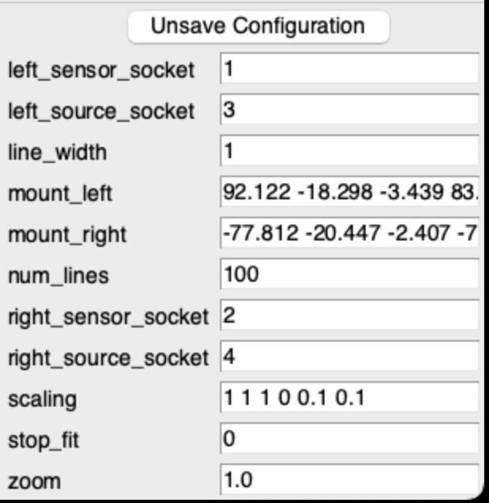
    - Depending on the camera settings you want to used, adjust the flash seconds in the CPMS manager, and if you are fitting objects in this experiment, adjust the threshold percentage. A good rule of thumb is to use an exposure of 40 ms (.04 in the settings) and 10% threshold.
    - To acquire save images for each set of measurements:
      - Pick the directory before taking any images, this is the location on the hard drive where the images will be stored. I recommend using the CPMS→Images folder in the C drive, and naming the folder with the date.
      - Acquire the image
      - Write the image before acquiring a new one. This will write the left and right images taken by the CPMS set up to the folder. The images are named after the unix time and “L” or “R” for the left or right camera
    - For each set of flange measurements with the faro arm, take an image of their position and save it before moving their position and re-measuring.
  - Faro Flange Measurements
    - For each flange position, you must define its pose. The pose is the location and the orientation of the flange. To define a flange’s pose, we use the axis of the middle cylinder, and the point where the axis intersects with the plane denoted by the large face of the flange. The point tells us the location, and the axis vector provides us with the orientation-- together they create the “pose”.
    - Plane creation: Create a plane feature by taking points on the face of the large cylindrical disc that faces the middle cylinder of the flange. Take about 5 points, name the plane “Lplane<position number>” for the larger flange or “Splane<position number>” for the smaller flange.
    - Cylinder creation: Create a cylinder feature and measure the middle cylinder with 10 points. Name the cylinder “Lcylinder<position number>” or “Scylinder<position number>”.
    - Extract cylinder axis: Highlight the cylinder feature in tree view, select the “line” feature, set the method to be “From Object”, “From Cylinder Axis”. Create the feature, naming it “Laxis<position number>” or “Saxis<position number>”/
    - Extract intersection/center point: Highlight both the previously created axis feature and the corresponding plane. Create a point feature, with the method set to “From Intersection”- this will create the point where the axis intersects with the plane. Name the point feature “Lcenter<position number>” or “Scenter<position number>”.
    - NOTE: When measuring the flanges and taking images, be sure to keep track of which image corresponds to which flange measurements. I usually document my flange measurements in polyworks with the position number, and if you take an image with the CPMS manager and write to disc for every set of measurements, the order of which the images are added will correspond with the flange measurement number. Be careful to only write each set of images once, and to make sure you write every image!!!

- Exporting Data
  - Highlight all the features in the tree view that you want to export. This general includes all of the coordinate spheres and measured objects. Right click and select “Report Table”
  - Hit “Ok” to the pop up icon.
  - Navigate to your report which is at the bottom of the tree view.
    - You can modify the layout of the report by adding or removing unnecessary text.
  - Right click on the report to export it as a text file.
  - Report measurements required for flange experiments:
    - Cone, Slot, Flat object measurements with X Y Z location for each sphere.
    - Cylinder measurements with diameter.
    - Axis measurements with X-midpoint, Y-midpoint, Z-midpoint, I, J ,K values.
    - Center measurements with X,Y,Z location.
- Troubleshooting
  - When there are issues with measurements, it is unlikely that the FARO arm itself is responsible. Usually, there are issues with the set up, the coordinate system. Below, I briefly go over some common issues.
  - Sphere or cylinder diameter is too large, too small, or the XYZ position is not precise:
    - The stand or stage to which the sphere is attached is shaky. This might cause the sphere to move when you press the probe to it, creating a point that does not align to the actual surface of the sphere.
    - Make sure you are obtaining points all around the sphere so that the location of the sphere in the coordinate system has differing points along the X,Y and Z axes.
    - You are taking too few points, 10 points for a sphere or cylinder is ideal.
    - Reduce shakiness, by propping up your arm so that you can hold the probing device securely.
    - The object itself is not uniform.
  - XYZ coordinates are not accurate
    - Check to make sure that the sphere positions you imported are correct and labeled properly. The Slot and Flat spheres should have a Y position of “0”, and the Cone sphere should have X,Y,Z coordinates of “0”. If the values are different, check the following:
      - If you have imported a global coordinate system, navigate to the coordinate system file from which you exported the spheres, and ensure that the active coordinate system within this file is “world”, aka the polyworks coordinate system. If this file has another coordinate system set, deactivate it. Save the file.
      - Then, do the following in this order:
        - Navigate to your current project file, re-set the coordinate system to the “world”.
        - Delete the last coordinate system you created, likely “Global”.
        - Delete the coordinate system that the previous one was derived from.
        - Delete the coordinate spheres.
        - Re-import the spheres from the coordinate system file, and recreate the coordinate systems.
    - The coordinate system file itself might have been configured improperly. Check to make sure that the sphere positions and diameters are correct and labeled properly.
    - You are not in the “Global” coordinate system you created. Activate this system.
    - Your global coordinate system was configured improperly when you set it, and the axes are incorrect.

If you have other issues, please email support@innovmetric.com with your question. They are very helpful.

